Test Case: tc006_SPX_Dev5_Validacion_Boton_AddNewMenu_Administrador_Menu
Step 1 - Enter username and password and click to button Enter : Credentials Entered
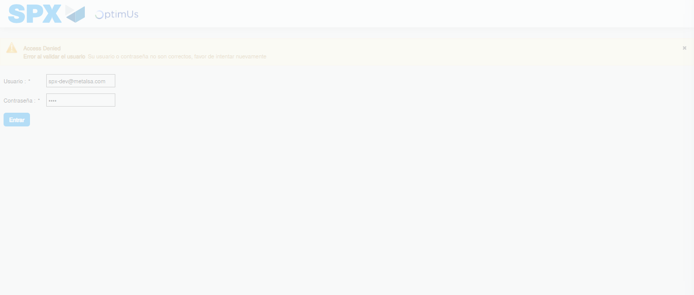Image file-name: QC_Testing-tc006_SPX_Dev5_Validacion_Boton_AddNewMenu_Administrador_Menu-nov. 20 2025, 03 42 22 p. m.

Image file-name: QC_Testing-tc006_SPX_Dev5_Validacion_Boton_AddNewMenu_Administrador_Menu-nov. 20 2025, 03 42 23 p. m.

Step 2 - Select to UEN and Access to Administrador Roles Menu: UEN Correctly selected and Correct access
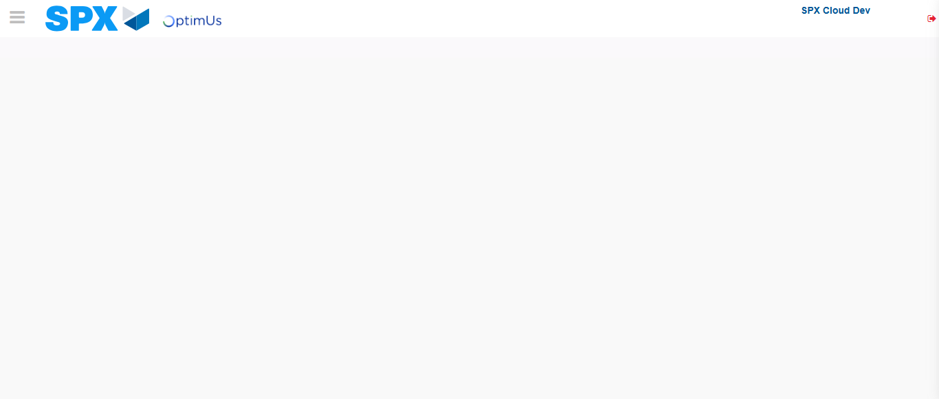Image file-name: QC_Testing-tc006_SPX_Dev5_Validacion_Boton_AddNewMenu_Administrador_Menu-nov. 20 2025, 03 42 31 p. m.

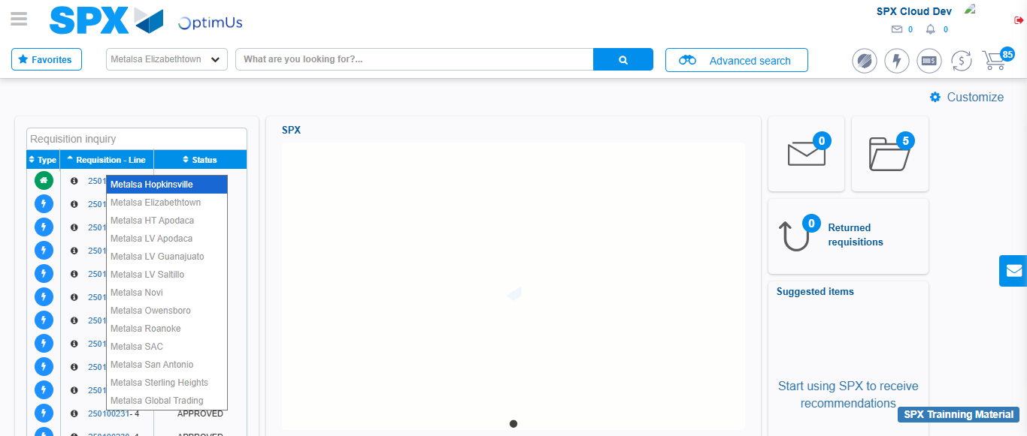Image file-name: QC_Testing-tc006_SPX_Dev5_Validacion_Boton_AddNewMenu_Administrador_Menu-nov. 20 2025, 03 42 32 p. m.

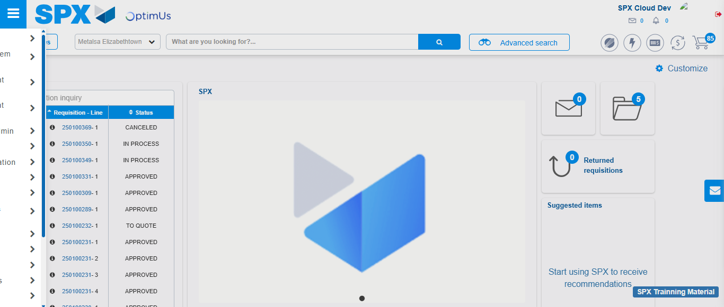Image file-name: QC_Testing-tc006_SPX_Dev5_Validacion_Boton_AddNewMenu_Administrador_Menu-nov. 20 2025, 03 42 33 p. m.

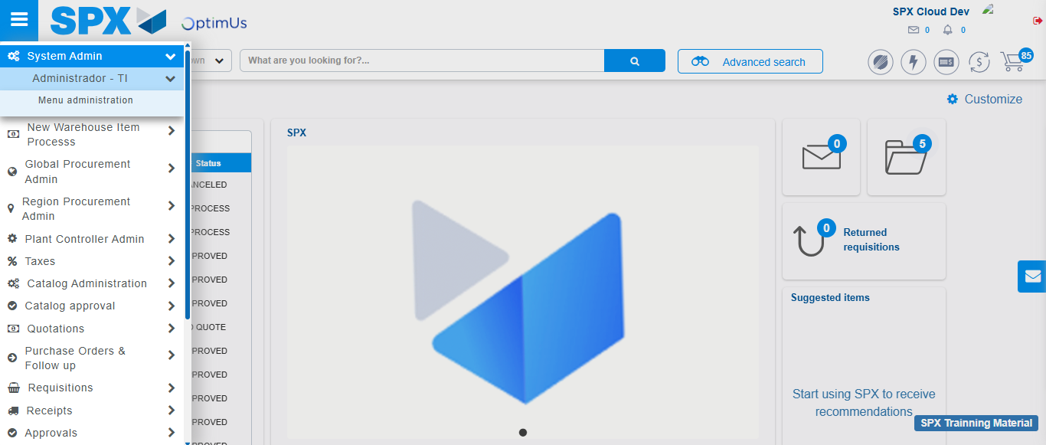Image file-name: QC_Testing-tc006_SPX_Dev5_Validacion_Boton_AddNewMenu_Administrador_Menu-nov. 20 2025, 03 42 34 p. m.

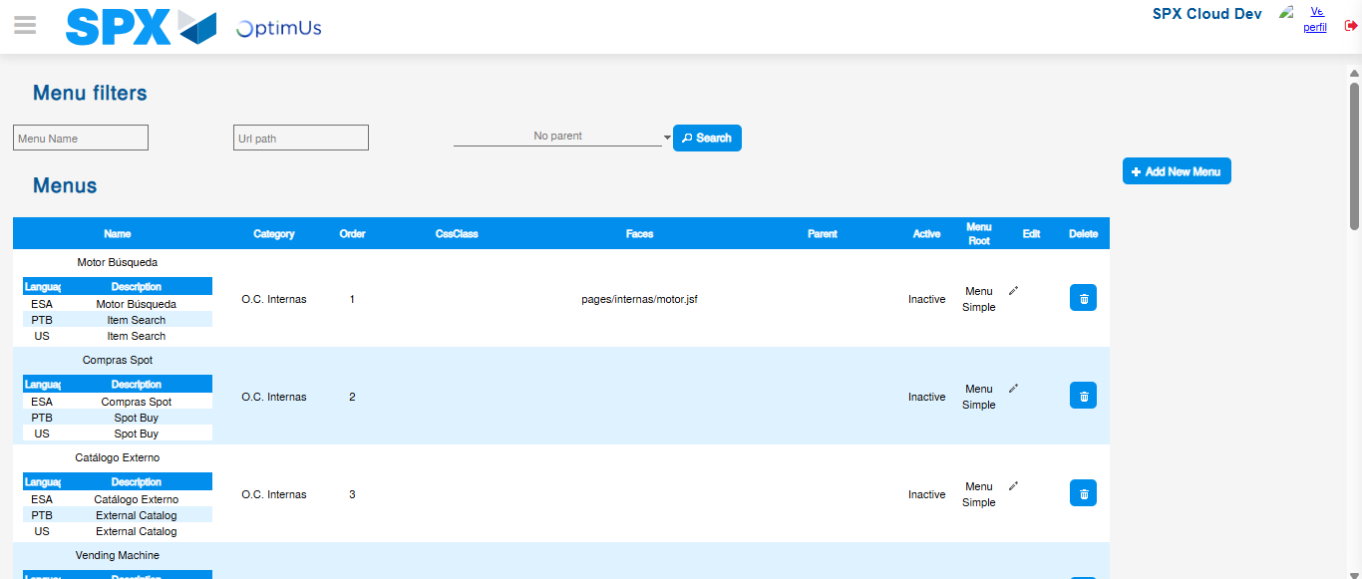Image file-name: QC_Testing-tc006_SPX_Dev5_Validacion_Boton_AddNewMenu_Administrador_Menu-nov. 20 2025, 03 42 37 p. m.

Step 3 - Perform a search with the URL Path filter: Successful search
Image file-name: QC_Testing-tc006_SPX_Dev5_Validacion_Boton_AddNewMenu_Administrador_Menu-nov. 20 2025, 03 42 37 p. m.

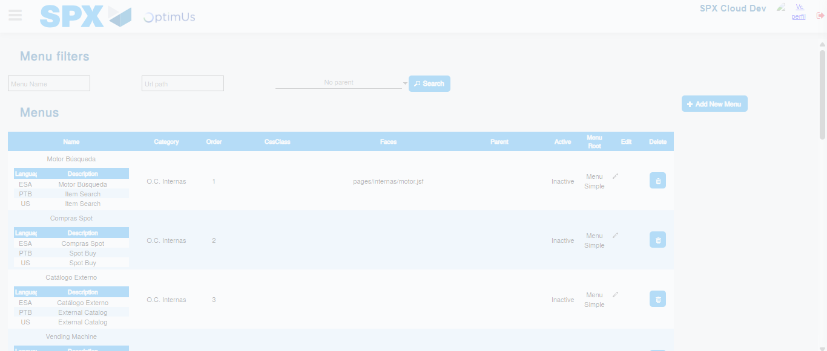Image file-name: QC_Testing-tc006_SPX_Dev5_Validacion_Boton_AddNewMenu_Administrador_Menu-nov. 20 2025, 03 42 38 p. m.

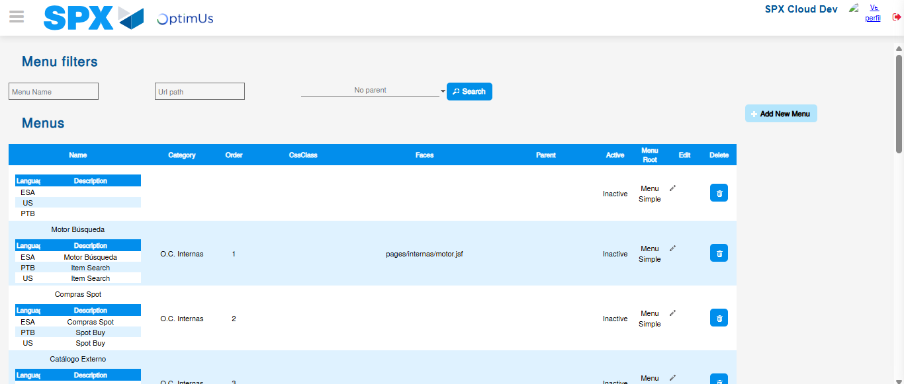Image file-name: QC_Testing-tc006_SPX_Dev5_Validacion_Boton_AddNewMenu_Administrador_Menu-nov. 20 2025, 03 42 41 p. m.

